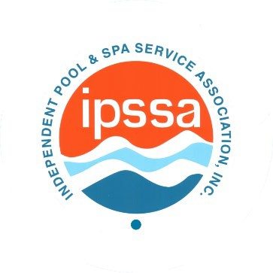
INDEPENDENT POOL & SPA

SERVICE ASSOCIATION, INC.

PO BOX 254645
Sacramento, CA 95865
888-360-9505
888-368-0432 (FAX)

IPSSA Board of Regional Directors Meeting Minutes from August 7, 2023

BORD Members Present:
Dvid Hawes, Region 1 Beau Braisher, Region 2 Eric Nielson, Region 3 Rick Morris, Region 4
Michael Denham, Region 5, CFO Scott Peterson, Region 6 Michael Harris, Region 7
Linda Cross, Region 8
Rick Beaubouef, Region 9. Assistant CFO Gary Heath, Region 10, Secretary
Todd Starner, President, Region 11

Contract Staff present:
Rose Smoot, CAE, Executive Director

Absent:
Casey Gardner, Vice-President, Region 12

- Call to Order and Anti-Trust Declaration
Starner called the meeting to order at approximately 5:05 p.m. PDT Attendees were read Anti-Trust declaration.
- MSC: Consent Agenda
- MSC: Approve value and organization propositions as presented.
Organizational values

*Professionalism *Community
*Service *Mentoring
*Education *Inclusion
*Credibility *Innovation

Value proposition

- “Improving the industry through community, education, and support.”

- Starner informed the BORD that Alcorn Law Firm and Smoot, have developed a draft bylaws and policy manual. Action: Starner to appoint two members of the board to work with Smoot on review of proposed draft bylaws and policy prior to the November BORD meeting. BORD to approve draft bylaws and policy at the November meeting.
- Planning Meeting outcomes.
  - Region 7 virtual chapter. After research it was determined by Harris that the region did not need to re-invent chapters.
  - Region 12 – membership tiers. Nothing to report.
- New Business action: BORD sent review of roles and responsibilities of liaison policy to the executive committee for their review and recommendation to the BORD at the November meeting.
A motion was made, and MSC reached to adjourn the meeting at approximately 5:54 p.m. PDT

